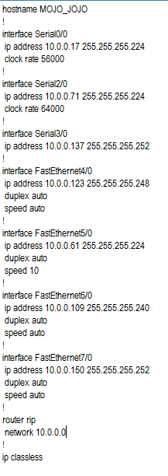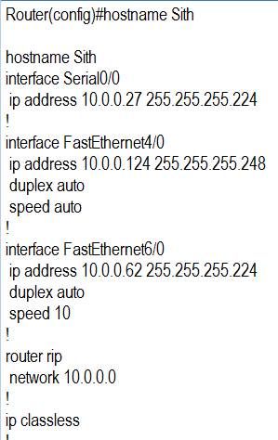

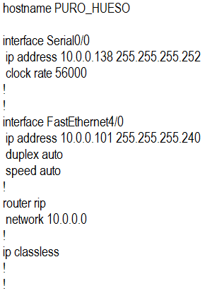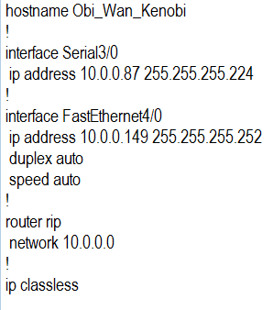

**ETAPA No 1 - PRACTICO**

Analice los archives Running Config de los Routers

* Sith
* Mojo_Jojo
* Puro Hueso
* Obi_Wan_Kenobi

Después de analizarlos responda las siguientes preguntas.

1. Haga un diagrama con la topología de la Red
2. Indique si existen errores en el diseño, ya sea en la configuración de los equipos o en el VLSM
3. Se desea implementar una red de 5 host, cual es la primera red que se le puede asignar, basados en el VLSM del problema.
4. Levante la tabla de enrutamiento para el router OBI_WAN_KENOBI.

**ETAPA No 2 - TEORICO**

1. Realice un diagrama o tablas donde se muestren los campos y valores de un mensaje DHCP-REQUEST en capa 2 y capa 3.
2. Explique las 4 capas jerárquicas del modelo de diseño de cisco.
3. Two connected routers are configured with RIP routing. What will be the result when a router receives update that contains a higher-cost path to a network already in its routing table?
   1. The update information will be added to the existing routing table
   2. The update will be ignored and no further action will occur
   3. The update information will replace the existing routing table entry
   4. The existing routing table entry will be delete from the routing table and all routers will exchange routing updates to reach convergence.
4. Cual es la capa del modelo OSI encargada del control de flujo, y explique como.,
5. What three primary functions does data link layer encapsulation provide? (Choose three.)
   * + addressing
     + error detection
     + frame delimiting
     + port identification
     + path determination
     + IP address resolution
6. Why do hosts on an Ethernet segment that experience a collision use a random delay before attempting to transmit a frame?
   1. A random delay is used to ensure a collision-free link.
   2. A random delay value for each device is assigned by the manufacturer.
   3. A standard delay value could not be agreed upon among networking device vendors.
   4. A random delay helps prevent the stations from experiencing another collision during the transmission.